MRM Modeling Principles, Definitions and Rules
v 1.0 March 2011

MRM Modeling Principles, Definitions and Rules
MRM Modeling Principles, Definitions and Rules 2
MRM Modeling Principles 3
MRM Modeling Definitions 4
Need 5
Organization Unit 7
Outcome 9
Output 11
Program 13
Service Integrated Accountability Model (SIAM) (Optional): each Program may be described by a SIAM diagram that traces the chain of accountability from its Services to its Target Groups. Service 16
Service 17
Service Value 22
Target Group 25
Disambiguation 27
MRM Glossary of Terms 28
Standard Attributes 34
Classifications 35
Program Field 35
Program Fields - Public 36
Program Fields - Enabling (a.k.a. Internal, Provider) 37
Service Output Types 38
Constructs (to come) 39
Use Cases (to come) 40
MRM Metamodel Diagrams 41
MRM Overview (Complete Metamodel) 42
Metamodel Essentials – Key Code Tables 43
Organization Structure (Centred on Organization Roles) 44
Services (Centred on Services) 45

MRM Modeling Principles
Principles for governing the definitions and rules used in MRM models.
The purpose of this document is to define the rules used to develop the content of the MRM Reference Model. The content of the Reference Model is composed of:
- A number of types of components, e.g. Programs, Services, etc.; these are sometimes called the ‘concepts’ defined by the MRM. A complete set of type definitions is provided in Annex 1.
- Many instances of each type, e.g. ‘Fire Program’, ‘Fire Suppression Service’, etc.; these could be thought of as a complete and consistent set of examples drawn from existing municipalities, that conform to the rules for defining an MRM-standard municipal business model, and serve as a short cut or template for creating one.
- Several facts (a.k.a. properties or attributes) about each instance that vary with its type, e.g. for the ‘Fire Suppression Service’:
  - Service Type: Public
  - Service Output Type: Intervention
- Several relationships (a.k.a. links or connections) between an instance of one type and instances of other types, e.g.:
Service | Administering Program

‘Fire Suppression Service’ | ‘Fire Program’
‘Fire Inspection Service’ | ‘Fire Program’
- This relationship is a fact expressing the rule that instances of Services are administered by instances of Programs
Every component in the Reference Model complies with a set of rules specific to that type of element. These rules are defined in this document and also in a specialized technical format in the MRM Metamodel. Generally, the rules determine:
- What is a valid instance of each type;
- What facts must be supplied about each instance;
- What relationships between instances must be declared.
Although these rules apply to the content of the Reference Model, they are also intended to be followed by individual municipalities when creating their own versions of an MRM-standard business model, to gain the most benefit from MRM features such as the ability to analyze and compare service delivery policies, operations and performance between different jurisdictions

MRM Modeling Definitions
Defines the components used in an MRM model, including component-specific rules
Change Driver (to come)
Location (to come)
Need
Organization Unit
Outcome
Output
Performance Indicator (to come)
Process (to come)
Program
Project (to come)
Resource (to come)
Service
Service Value
Target Group

Need
Definition:
A Need is defined as a condition wanting or requiring relief.
An expression of Need is a particular manifestation of an underlying Need.
A recognized Need is an expression of Need that the government acknowledges its obligation to address.
If thirst is the primary Need, needing water and needing access to water are expressions of that Need. The government recognizes both but addresses the first with public water fountains and the second with a supply of potable water to homes and businesses.
Naming:
- Defining and naming Needs is a policy task, requiring distinctions between Needs, wants and requirements among other things. A Need’s name should be carefully chosen so as to be re-usable in different contexts and to enable a view of the jurisdiction’s services through the lens of each Need.
  - As much as possible, avoid reflecting a specific Program or Service in the name, e.g. ‘Protection from Violence’ rather than ‘Police Patrols’.
  - Names should be as general as possible to allow them to be used with different Target Groups. For example, ‘Protection from hazards’ is addressed differently when expressed by senior citizens compared with children. For the former, residences might be upgraded and for the latter, barriers built around dangerous places. The value in this approach goes to policy and strategy development, allowing better recognition of the different contexts and ways similar Needs are expressed.
  - Both Maslow’s Hierarchy of Needs (or its superseding versions) and the Public and Provider Program Fields (Annex xxx) are useful to understand how to name and describe Needs. The two frameworks are complimentary: Maslow offers a view of individual Needs that can have different expressions in the different contexts presented in the Program Fields.
Valid Instances:
- Valid Needs are those recognized by the government in policies, legislation, etc. Generally, the existence of a Program recognizing the Need provides both the evidence and the information required, but the Need must be identified and defined appropriately.
- Any Need which is an expression of a broader or more general Need should be logically related to that more general Need. 'Protection from hazardous construction' is a natural specialization of 'Protection from built hazards', but not 'Protection from natural hazards '.
Attributes:
- Standard Attributes.
Relationships:
- Needs are associated with Outcomes (Mandatory):
  - Each Need should be associated with at least one Outcome and potentially many. The Outcome connects the Need with a Target Group and establishes the basis for measuring the effectiveness of Services addressing that Need.
    - Example: the Need for 'access to potable water' can be related to the Target Group 'residents' by the Outcome "safe and adequate residential water supply'.
- Needs can be subsets or supersets of other Needs (Optional):
  - A Need should be associated with another 'parent' Need if it is part of that broader or more general Need.
    - Example: the Need ‘Protection from Violence’ is a superset of the Needs ‘Protection from Spousal Violence’ and ‘Protection from Street Gang Violence’.

Organization Unit
Definition:
An Organization Unit is a point of authority, accountability or responsibility commanding resources commensurate with its obligations.
The term 'point' can refer to an office, position, committee, appointment, chair, etc.
Naming:
- Organization Unit names can be those used by the existing organization, but there may be additional requirements.
- In many cases, the governance structure is not sufficiently well defined to establish all key roles in the business model, especially related to Programs. Governance bodies may need to be added, such as a Senior Management Team, a Human Resources Policy Committee, external regulators, other jurisdictions, partners, or even less formal groups such as associations of agencies.
- One common technique is to name appropriate Organization Units as ‘Offices’ to distinguish the authority from the person, as in ‘Office of the CAO’, or ‘Office of the Mayor’. Whether these names are expressed as ‘CAO’ or ‘Office of the CAO’ is a style question, but the approach taken should be used consistently.
Valid Instances:
- An Organization Unit is valid if it exists, existed at one time, or is planned.
- Only those instances required for analysis should be added to the model, because it is expensive and time-consuming to keep role and responsibility information up-to-date without sufficient justification.
  - Example: when using the model as a strategy tool to analyze and plan at the Program and Service level, avoid defining Organization Units below those needed to take responsibility for Program and Services.
  - Example: when using the model as a systems development tool to analyze Services and Processes, only define that portion of the Organization impacted by the systems development project to the necessary level of detail.
Attributes:
- Standard Attributes
- Budget 1, Budget 2, Staff 1 (Optional): undefined at this time.
- Mission (Optional): provide a concise description of the Organization Unit’s Mission.
- Vision (Optional): provide a concise description of the Organization Unit’s Vision.
Relationships:
- Organization Unit reports to Organization Unit (Mandatory):
  - Every Organization Unit should be associated with the Organization Unit to which it reports.
- Organization Unit Is accountable for Programs (Optional):
  - Each Organization Unit should be associated with each Program whose associated Outcomes it is accountable for.
- Organization Unit is accountable for Services (Optional):
  - Each Organization Unit should be associated with:
    - Every Service for which it is accountable in terms of Service Outputs
    - Every Service with which it has a RASCI relationship (see Services).
- Organization Unit Is responsible for Processes (Optional):
  - Undefined at this time.
- Organization Unit has authority over Resources (Optional):
  - Undefined at this time.

Outcome
Definition:
An Outcome is a desirable change in the level of a Target Group Need resulting from Service delivery.
Naming:
- The name for an Outcome should be prescriptive, making explicit references to the Target Group, recognized Need and desired trend forming the Outcome, as in ‘Reduced infant death rate’ or ‘More prosperous community’.
Valid Instances:
- A valid Outcome requires the pairing of a valid Target Group with a valid Need.
- A valid Outcome requires an Organization Unit to be accountable for a Program that delivers it.
- A valid Outcome must have a measure or measures that establish the change in level of Need.
Attributes:
- Standard Attributes
- Target Level: measure(s) of Target Group Need intended as a result of achieving this Outcome.
- Achieved Level: measure(s) of Target Group Need actually accomplished
Relationships:
- Outcomes are achieved through Service Value of Outputs
  - Each Outcome should be associated with one or more Outputs.
  - There should be a very direct and tangible cause-and-effect relationship between the Output Value and the association between a particular Output and Outcome.
    - Example: Since building permits enable construction to proceed, they contribute to the Outcome ‘Increasing municipal economic activity’.
  - Tip: The relationship between Outputs and Outcomes can be reflected in a PLM diagram.
- Outcomes are achieved through contributions from other Outcomes, and contribute in turn to other Outcomes
  - An Outcome may be associated with another Outcome to represent the fact that one contributes to the other in a logical way, or from evidence.
    - Example: reducing the incidence of breast cancer contributes to a reduction in the incidence of cancer in the general population (logical relationship); reducing the incidence of smoking contributes to a reduction in mortality and morbidity due to cancer (evidence-based relationship).
  - In the set of Outcomes delivered by a Program, the following cases occur:
    - Immediate or Direct Outcomes are those associated with any Outputs
    - Intermediate Outcomes are those with contributing Outcomes and that in turn contribute to other Outcomes
    - Strategic Outcomes are those with contributing Outcomes but that do not contribute to further Outcomes, i.e. that end the chain of cause-and-effect
  - Tip: The relationships among Outcomes should be reflected in a PLM diagram.
- Outcomes are the mandate of Programs
  - Each Outcome should be associated with one Program.
  - If there is no existing Program with a mandate for a particular Outcome, one should be created.
- Outcomes are associated with Target Groups
  - Each Outcome should be associated with one Target Group.
  - If there is no appropriate Target Group, one should be defined.
- Outcomes are associated with Needs
  - Each Outcome should be associated with one Need.
  - If there is no appropriate Need, one should be defined.

Output
Definition:
An Output is a unit of value produced by a Service and conveyed to a Service Recipient.
Naming:
- An Output’s name should be concrete, focusing on the ‘unit’ that is conveyed, not the value it creates or the Outcome it achieves.
- Example: an instructional Service’s Output might be named ‘swimming course’ or ‘water safety class’, not ‘education’ or ‘learning’, to indicate more clearly the nature of the work needed to produce and deliver the Output and the measures of efficiency and quality that might apply to that Output.
- The instances of a Service’s Output can exhibit a range of features, characteristics and configurations, but the name chosen should encompass all of them. The need for several different names is an indication that several different Services may be required.
- The Service Output Types are not intended to be (and should not be used as) Output names, but are helpful in conceptualizing the ‘units of value’ for each type of Service.
Valid Instances:
- If the Service producing it is valid, the Output is valid provided that:
  - It can be satisfactorily classified by just one Service Output Type (see Attributes below);
  - It is produced repetitively by its Service (i.e., more than once);
  - It is the sole Output for its Service (with the understanding noted elsewhere that instances of the Output may vary slightly from each other).
Attributes:
- Standard Attributes
- Volume Count – Planned (Optional)
  - A count of the intended instances of Output to be produced in a timeframe.
- Volume Count – Actual (Optional)
  - A count of the actual instances of Output produced in the timeframe.
- Volume Period Start (Optional)
  - The starting point of the timeframe for counting Output volumes.
- Volume Period End (Optional)
  - The ending point of the timeframe for counting Output volumes.
- Service Output Type (Mandatory).
  - See Service Output Types
  - Each Output must be classified by one (and only one) Service Output Type.
- Output Type (Mandatory)
  - S – Service Output: Output is produced by a Service
  - P – Process Output: Output is produced by a Process
  - See Disambiguation Page
Relationships:
- Outputs are produced and delivered by Services (Mandatory)
  - Each Output should be associated with a single Service producing it.
- Outputs are composed of Outputs (Optional)
  - Service Outputs may be associated with one or more Process Outputs to define their composition in more detail. More information can be found under Processes.
  - Process Outputs may be associated with one or more other Process Outputs to define their composition in increasing levels of detail. More information can be found under Processes.
- Outputs create Service Value (Mandatory)
  - Each Output should be associated with at least one and potentially many Outcomes to indicate that the Output is intended to contribute to each related Outcome, i.e. affect its performance indicators.
  - If there is no Outcome associated with an Output, one should be created.

Program
Definition:
A Program is a Mandate to achieve Outcomes by delivering Services.
Naming:
The typical Program name is a concise description of the Target Group(s) and either the Need(s) addressed, e.g. ‘Public Health’, ‘Family Safety, or the most strategic Outcome(s) desired, e.g. ‘Community Prosperity’, ‘Ontario Works’, ‘Downtown Revitalization’, ‘No Child Left Behind’. Program names may also be brands, e.g. ‘Apollo Program’.
Tip: It is sometimes useful to append the term ‘Services’ to the chosen name as a test of its message; for example, ‘Apollo Program Services’ does not convey an accurate idea of the Program's operation, suggesting it is a brand name, whereas 'Downtown Revitalization Services' implies correctly that Services are available to improve the downtown economy.
Valid Instances:
- A Program should administer at least one valid Service or two or more Sub-Programs to be a valid Program. While single-Service Programs do appear, it is more often the case that a Program administers a number of Services.
- Programs formed by grouping similar Services together only because they use the same resources, or are functionally similar, should be examined carefully. For example, a Service offering swimming instruction for persons with disabilities may be better administered by a Chronic Care Program (from an Outcomes perspective) rather than by a Recreation Program, even though the latter is equipped to offer other forms of swimming instruction.
Attributes: (Mandatory/Optional)
- Standard Attributes
- Program Formality - Formal/Informal (M)
  - A Program can have a formal or informal identity in a jurisdiction. Formal
Programs should be recognized in an MRM model, but informal Programs can also be useful. The following guidelines help determine which designation to use:
    - Formal Programs are often identified by an explicit level of governance (e.g. a departmental executive committee) and accountability for meeting a range of designated Needs, with commensurate authority over resources. A formal Program usually
defines common Outcomes with Performance Indicators and integrated Goals for the sub-Programs and Services administered by it, and manages, coordinates and allocates resources to its Services so as to best achieve those goals. A formal Program is likely to:
      - be expressly mandated by policy, legislation, by-law, etc. or other form ofauthority
      - have explicit governance mechanisms and performance indicators
      - be associated with one accountable Organization Unit
      - be explicitly recognized in the jurisdiction’s operating budget
    - Informal Programs can appear as a grouping of Services and sub-Programs around some related Needs or theme, for purposes of reporting, policy analysis, branding, communications, etc. An informal Program is likely to:
      - be identified more as a broad unifying theme in a vision statement, planning document, etc. than as the focus of one Organization Unit
      - be made up of formal Programs and sub-Programs
      - be governed - if at all - by a committee or commission, or by the jurisdiction's CAO and executive management team
      - have only a project or capital budget.
- Program Type Public/Enabling/Transformational (M)
- Need Category (M).
  - The Program Field classification is applied to both Programs and Services.
  - Programs administer multiple Services, and each Service can address multiple Needs (i.e. can be classified under multiple Program Fields).
  - Taking into consideration the classifications of the Services under its administration, a Program should be assigned one or more Program Field classifications, with a typical number being one to three.
  - Program Field assignment should be in priority sequence, beginning with the highest priority Need addressed by the Program – typically the one justifying or motivating the Program’s existance.
  - Public Programs should be classified by Public Program Fields. Enabling Program should be classified by Provider Program Fields.
- Vision (O): Description of the Program's vision and expected Outcomes.
Relationships: (Mandatory/Optional)
- Programs have accountable Organization Units (O)
  - A formal Program must be associated with (must be the accountability of) exactly one Organization Unit.
  - An Organization Unit can be associated with (accountable for) many Programs, but not necessarily any.
  - The implication of the relationship is that the Organization Unit takes accountability for achieving the Program’s Outcomes, and is measured by the Performance Measures associated with those Programs.
  - Organization Units accountable for Programs are typically the Office of an executive, e.g. Chief Administrative Officer, Office of the Commissioner, Office of the Chief Financial Officer, etc.
  - An informal Program may be associated with a typical Organization Unit, but could also be associated with a body such as a committee, whose accountability for the Program may also be informal.
- Programs administer Services (M)
  - Programs should be associated with one or more Services that are administered by the Program.
  - If no existing Service can be associated with a Program, one should be created.
- Programs have Sub-Programs (O)
  - Programs can exist in hierarchies. A Program may be composed of lower-level Programs (Sub-Programs), or aggregated together to form higher-level Programs (Super-Programs).
  - A Sub-Program can be accountable for a subset of the Outcomes of its parent Program. This typically means that the Sub-Program administers a subset of the Services administered by its parent Program.
  - The subsets of Services and Outcomes administered by a Sub-Program can take different forms, e.g.:
    - Geographic, e.g. downtown vs. suburban economic development Sub-Programs;
    - Functional, e.g. crisis-response vs. rehabilitation Sub-Programs of a Social Welfare Program
  - A Super-Program can take accountability for Outcomes that are beyond the direct control of its Sub-Programs. The requirement for this typically arises when a number of Programs must be coordinated to achieve a strategic vision or goal, e.g.:
    - Environmental protection Programs may have distinct Services, but typically also require coordination across economic development Programs, transportation Programs, etc.
  - A hierarchy of Programs enables the jurisdiction to align organization and governance structures with the hierarchy of accountability for Outcomes.
- Programs are accountable for Outcomes (M)
  - A Program should be associated with one or more (typically a set of) Outcomes, expressing the Program’s accountability for those Outcomes.
  - The Outcomes for which a Program is accountable are typically related in some way, usually by related Target Groups or related Needs or both.
  - The direct relationship between Programs and Outcomes does not duplicate the linkages between Programs, Services, Outputs and Outcomes. Services are associated with lower-level ‘direct’ Outcomes via their Outputs whereas Programs are associated with the same Outcomes as their Services, but also with higher-level Outcomes.
  - The Program Logic Model also expresses these relationships.
Constructs:

- Program Logic Model (PLM) (Optional): each Program may be described by a PLM diagram that explains the contributory relationship of the Program’s Services to its expected Outcomes.

Service Integrated Accountability Model (SIAM) (Optional): each Program may be described by a SIAM diagram that traces the chain of accountability from its accountable Organization Unit to its administered Services to its Target Groups.

Service
Definition:
A Service is a commitment to deliver Outputs that contribute to Outcomes.
Naming:
The name of a Service should be defined as a combination of “modifier” (optional), “noun” (mandatory) and “gerund” (mandatory). For example, a Service should be named ‘Solid Waste Collection’ rather than ‘Solid Waste’. Modifiers are not always required, e.g. Business Licensing. The Service's name should make sense with and without the word “Service” following the name when required by context.
Valid Instances:
- The Service should be the expression of an obligation created by policy, bylaw, etc. to respond to all legitimate requests; otherwise the Service is typically some discretionary activity. (Obligation Rule)
  - Example: the occasional and discretionary sale of surplus government assets is not a Service because there cannot be an obligation if there are no surplus assets.
- The Service’s existence should not depend essentially on the existence of another Service; if that is the case, the activity is typically a feature or configuration of that other Service. (Independence Rule)
  - Example: traffic control and signage are not Services because they depend on the existence of the ‘Roads Service’. Traffic control and signage are features that increase the quality and effectiveness of the ‘Roads Service’ because they enable more, safer, and more convenient trips.
- Delivery of the Output defined for the Service should fully satisfy the Need(s) addressed by the Service, commensurate with the intentions of the government and the legitimate expectations of the client. (Closure Rule)
  - Example: fixing a pothole does not by itself satisfy a driver’s expectation of a trip, nor the government’s intent to enable it, and is therefore not a Service but a Process forming part of the ‘Roads Service’. Absence of potholes is a quality metric signalling the degree of comfort and safety of the driver’s trip, and pothole fixing should be seen as a Process performed to maintain or increase the quality of the ‘Roads Service’.
  - Example: processing an application form for a building permit does not by itself satisfy a client’s need for permission to build, nor the government’s intent to grant compliant requests, and is therefore not a Service but a Process forming part of the ‘Building Permit Service’. Note that this rule does not imply that the service relationship between the government and the client necessarily ends at the time or point of delivery of the defined Output. Issuing the permit could be followed by other processes to ensure it is posted at the site, its conditions complied with, etc.
- Material work should be performed by the Service, i.e. energy and resources should be intentionally expended to produce each instance of the Service’s Output. (Materiality Rule)
  - Example: even if the actions arise out of a customer service policy, holding the door open for seniors entering City Hall is unlikely to qualify as a Service by itself, but rather as an activity increasing the experienced quality of many other Services.
The following validation rules apply primarily to Enabling Services:
- A Service should have at least two clients, and each should be able to request the Service’s Output completely independently of each other; otherwise the Service is typically a Process in a Service provided by the single client ordering it. (Two or More Clients Rule)
  - Example: the government’s resources and processes for analyzing water quality do not form a Service if they are only used by a single water treatment plant – they are a Process forming part of the Water Supply Service offered by that plant. Conversely, if the Water Supply Service has many water treatment plants that can each independently request a water quality analysis, those resources form an Enabling Service.
This rule applies in a straight-forward way to insourced processes and resources, and may also apply in cases where they are outsourced.
Example: if a private vendor or vendors provide water quality tests to water plants but each water plant takes individual accountability for testing accuracy, then the processes and resources involved do not form a separate service. However, if one part of the Organization Unit responsible for the Water Supply Service takes sole accountability for providing accurate water quality tests to many water plants, then a separate Enabling Service is formed even if that unit outsources the work to private vendors.
- The Service’s Output cannot be mandatory for all members of its Target Group; otherwise the Service is an Enterprise Management Process or Program Management Process. (Non-Mandatory Rule)
  - Example: developing a strategic plan is not a service if each department must participate in it. If, on the other hand, an Organization Unit offers assistance with the preparation of individual strategic plans, e.g. departmental or program plans, then an Enabling Service is formed.
Attributes:
- Standard Attributes
- Service Type (Mandatory).
  - A Service should be typed as Public or Enabling.
    - Alternative labels for an Enabling Service are: Provider Service; Internal Service; Support Service. One term should be chosen and used consistently within a municipality or project.
  - Public Services serve members of the public directly and address Needs that are classified by Public Program Fields.
    - Example: the Fire Suppression Service serves property occupants and owners, and addresses the need for protection from fire, which is classified as Public Safety.
  - Enabling Services serve organizations that are part of, or agents of, the government and address needs that are classified by Provider Program Fields.
    - Example : a Staff Recruiting Service serves managers in the organization and meets their need for recruiting expertise and resources.
  - Where Services appear to serve and address both public and enabling needs, e.g. a Service to fund organizations that in turn provide services to individuals, the type should be:
    - Public where the agency is essentially under contract to the government to provide designated services to specific members of the public;
    - Enabling where the agency can use its own discretion vis-à-vis the services it offers and the clients it accepts, and where the government’s role is essentially to provide resources.
- Program Field (Mandatory).
  - Services can be intended to address multiple Needs. The Service should be assigned one or more Program Field classifications, where each Program Field indicates a type of Need addressed by the Service. A typical Service has at least one and sometimes up to three classifications.
  - Program Field assignment should be in priority sequence, beginning with the highest priority Need – typically the one motivating and justifying the Service’s creation.
  - Public Services should be classified by Public Program Fields. Enabling Services should be classified by Provider Program Fields.
Relationships:
- Services are administered by a Program. (Mandatory or Optional, as determined by the municipality or project.)
  - Each Service should be associated with one Program. A Program can be associated with one or more Services.
  - Programs can be a formal or informal concept in a jurisdiction, but this should have no bearing on the relationship between Services and Programs. See Programs in this document for further information
  - If there is no Program to administer a Service, one should be created.
- Services can be composed of Sub-Services or aggregated into Super-Services. (Optional)
  - Services may form a hierarchy. A Service may be made up from one or more lower-level Services, which can be called its Sub-Services or aggregated with other Services to form a higher-level Service, which might be called its Super-Service.
    - Example: ‘Recreational Instruction’ might be formed from ‘Swimming Instruction’, ‘Skating Instruction’ and ‘Soccer Instruction’
  - A Service hierarchy makes it possible to perform various management tasks efficiently on an appropriate group of Services in the hierarchy. For example, budgeting and reporting might be performed on one higher-level Service, while measuring effectiveness and policy review might be performed on lower-level Services.
  - The Outputs of all Services in any given hierarchy must always be classified by the same Service Output Type.
  - All Services at all levels must conform to the rules for any Service.
  - A Service that is not composed of lower-level Services can be called a 'leaf-level' Service. It may be leaf-level because there is no further disaggregation possible (or evident in any jurisdiction), or because there are so many potential Sub-Service variations that a full accounting may not be possible.
    - Example: ‘Skating Instruction’ can have many variations based on specializing the Service’s Output, Target Group(s) and Need(s):
      - ‘Public Skating Instruction’ (least specialized)
      - Skating instruction for persons with disabilities (more specialized Target Group and Need)
      - Skating instruction for youth (more specialized Target Group)
      - Speed skating instruction for youth (more specialized Target Group and Output)
      - Etc.
    - The point to be taken from this example is that all the variations shown are possible and in fact might all be offered within a jurisdiction at the same time depending on circumstances, making the most appropriate Super-Service simply ‘Skating Instruction’ with no further qualification.
- Services produce and deliver Outputs (Mandatory)
  - Each Service should be associated with one Output, and an Output can only be associated with one Service.
  - If there is no Output that can be associated with a Service, one should be created.
- Services are accounted for by Organization Units (Optional)
  - Each Service may be associated with one or more Organization Units.
  - The relationship between a Service and each Organization Unit may be classified according to the RASCI formula:
    - Responsible: obligated to respond to Service requests
    - Accountable: reports Service performance and accepts consequences
    - Supporting: provides resources enabling Service operations
    - Consulted: two-way communication supporting Service operations
    - Informed: one-way communication concerning Service operations

Service Value
Definition:
A Service Value defines the expectations of parties receiving the Service's Output directly or indirectly, and ensures their alignment with associated Service Objectives and Outcomes.
Consider the following straight-forward example from the perspective of service analysis:
- A Program aims to increase youth employment. This is an Outcome, linking a Target Group (unemployed youth) with a recognized expression of Need (employment) and a desirable trend (increase).
- Among the various Services offered by the Program is the "New Job" Service that provides skills training (an Output) designed to increase the student’s potential job opportunities, and increase their conversion rate from job applicant to employed (two Service Objectives).
- The Outcome and Service Objectives are aligned in theory, because the objectives if realized will produce an increase in youth employment. In practice, each must be measured to validate the theory.
- The Service Value expresses the analyst’s view of the Target Group’s expectations of the Service, and brings motivation into the analysis. If the Service Value is expressed as “more chance of a job” then all three aspects – Outcome, Service Objectives and Service Value - are aligned because unemployed youth can be presumed to be motivated to take up the Service, or in other words, to behave accordingly. Once again, that presumption will have to be tested by measuring the degree of takeup. If measures showed that more employed than unemployed youth applied for training, then one explanation would be that the Service Value is experienced as “chance of a better job”.
Valid Instances:
- Any valid Output and valid Outcome can form a valid instance of Service Value.
Naming:
- A Service Value name should bring in a reference to both Service and Target Group. This can be easily expressed in a variety of ways:
  - 'New Job training value to youth' - Service and Target Group
  - 'Job skills value to youth' - Output and Target Group
  - 'Job skills value to New Job students' - Output and Clients
  - 'New Job training value to students' - Service and Clients
- Service-specific names like New Job students are completely appropriate and even desirable, because they can be easily mapped to their corresponding Target Groups in the associated Outcomes.
Attributes:
- Standard Attributes
- Client Indicator (M) - is the Target Group referenced in the Outcome associated with this Service Value a 'client'?
  - Yes - members of the Target Group perform one or more of the following actions: order the Service; engage directly with the Service; receive the Output of the Service; control or have the disposition of the Output; identify themselves to the Service.
    - Example: youth in the example cited above are clients of the Service because members of that Target Group order the Service Output, it is conveyed to them, and they take receipt.
  - No - members of the Target Group are affected by (typically benefit from) service delivery but indirectly.
    - Example: children with disabilities benefit from grants received by their parents for medical aids. Parents are the client Target Group and children with disabilities are a Target Group but not clients.
- Beneficiary Rank (M) - the relative importance of this Service Value, compared to other Service Values associated with the same Output.
  - Values range from 1 (most important) to 5 (least relative priority and importance).
  - There should always be at least one Service Value with rank 1, with the implication that the related Outcome, and the Target Group Needs it points to, motivate and justify the existence of the Service, and in their absence, the Service would disappear regardless of other beneficiaries.
    - In the New Job example cited above, since there is only one Service Value, its rank is 1 (highest priority and importance).
    - In the example where parents receive grants to provide medical aids to their children with disabilities, the Service Value pointing to children would typically rank 1 (most important) and that pointing to the parents would rank 2. The implication is that were the decision taken not to aid children with disabilities, the ancillary benefit to the parents is not sufficient to justify continuing the Service.
- Service Value (M) - a.k.a. 'value proposition'; expresses the Target Group’s expectations of the Service in the context of their Need, and in terms of results or consequences arising from delivery of the Output.
- Service Objectives (M) - identifies the results to be realized directly by the Service, often expressed in terms of:
  - Increased capacity, ie. Target Group members taking up the Service have more resources
  - Increased capabilities - they are more capable of dealing with demands, have more skills
  - Increased influence - they have more knowledge and awareness
  - Decreased undesirable behavior - they move closer to social norms
- Planned Client Set (O) - the number of Target Group members expected to take up (be served by) the Service.
- Served Client Set (O) - the number of Target Group members actually served.
- Client Set Takeup (O) - the number of actual applicants for the Service as a percent of Target Group size. Note that this could include applicants who do not qualify for service delivery.
- Achieved Service Level (O) - the number of Target Group members actually served as a percent of total Target Group.
Relationships:
- Outputs are associated with one or more Service Values (M):
  - Each Output must be associated with at least one Service Value and may be associated with more than one
- Outcomes are associated with one or more Service Values (M):
  - Each Outcome must be associated with at least one Service Value and may be associated with more than one.

Target Group
Definition:
A set of Parties that share intrinsic or extrinsic characteristics causing a Program to identify (target) them.
Naming:
- Defining and naming Target Groups is a policy task. A Target Group’s name should be carefully chosen so as to be re-usable in different contexts and to enable a view of the jurisdiction’s services through the lens of each Target Group.
- The name should defined without reference to any particular Service or Program, e.g. ‘Residents’, rather than ‘Water Users’
- For Target Groups of Public Programs and Services, the name can reflect:
  - Intrinsic or extrinsic population characteristics, e.g. Children, Small Businesses, etc.
  - Roles, e.g. Property Owners, Tenants, Residents, Visitors, Drivers, etc.
- For Target Groups of Enabling Programs and Services, usually only Roles can be identified, e.g.
  - Managers, Field Workers, Agency Staff, etc.
  - The name should imply a countable set, e.g. Head Office Staff not Head Office, or McDonald’s Employees not McDonald’s.
Valid Instances:
- The previous rules for naming a Target Group are also relevant to identifying Target Groups, but there are several additional principles.
  - Target Groups must have more than one member; e.g. the Director of one branch is not a Target Group, but Directors in the jurisdiction could be.
  - Target Groups should generally be formed in one of two ways: aggregating or sub-dividing existing Target Groups
    - Target Groups can be formed by sub-dividing known Target Groups. 'Children' might be sub-divided to distinguish 'Infants' and 'Public-School Age Children'.
    - Target Groups can be made up by combining existing Target Groups, provided all members of the combined set play the same role with respect to the Program or Service in question. For example, 'Property Owners', 'Landlords' and 'Tenants' are distinct Target Groups in the context of many government Services, but could be combined as one Target Group for an Information Service about rental policy and legislation.

Attributes:
- Standard Attributes.
- Target Group Type (Mandatory):
  - (P)ersons - members are natural persons, e.g. 'children'; each member is a legal party with rights and obligations recognized in law.
  - (O)rganizations - members are legal, not natural, persons, e.g. 'businesses'; each member is a legal party with rights and obligations recognized in law.
  - (G)roups - each member comprises two or more legal parties, e.g. 'families', 'neighbourhoods'; members are not legal parties and may or may not have rights and obligations recognized in law.
  - (U)nspecified - provide an explanation of the members of the Target Group in its description.
Relationships:
- Target Groups are associated with Outcomes (Mandatory):
  - Each Target Group should be associated with at least one Outcome and potentially many. The Outcome specifies the nature of the Need expressed by the Target Group that is recognized by the government.
- Target Groups can be subsets or supersets of other Target Groups (Optional):
  - A Target Group should be associated with another Target Group if the former is part of the latter or vice-versa.
    - Example: the Target Group ‘Infants’ is a subset of the Target Group ‘Children’ because the members of former are also members of the latter. ‘Infants’ is a subset of ‘Children’ and ‘Children’ is a superset of ‘Infants’.

Disambiguation
Separates similar terms with different meanings and vice-versa.
Output:
- Output - when this term is used without modification, it means Output of a Service, the final valued output produced by a Service. It may also be referred to as a Service Output if the meaning is not clear in context.
- Process Output - the output produced by a Process in the MRM.
- Relationship: one or more Process Outputs make up a Service Output.
Process:
- Process - when this term is used without modification, it means a Process that is part of a Service, i.e. performed entirely by the Service. It may also be referred to as a Service Process if the meaning is not clear in context.
- Business Process - the work performed from the point an input is received by the enterprise, to the point when a corresponding output from the enterprise is produced. This is the generally accepted definition of a business process.
- Relationship: a business process may be made up of several (Service) Processes, either from the same Service or from different Services.

MRM Glossary of Terms
Defines the common language provided by the MRM
Tip: The definitions in this glossary are not intended to be universal, but to apply in the context of developing an MRM model.
A
Accountability: the obligation to report - 'account for' - the results of performing actions, and accept the consequences. In an MRM model, this obligation is held by an Organization Unit in relation to a Program or Service.
- Horizontal Accountability - the accountability of a Service to its Clients for the Quality of its Output.
- Vertical Accountability - the accountability of a Service to its administering Program for the Efficiency and Effectiveness of its Output.
Agents - parties that act on behalf of members of Target Groups in transactions with a Service. In MRM modeling, Agents can be ignored when recognizing them serves no analytic purpose, e.g. when someone can pay a parking fine on another's behalf. However, parties acting as Agents can form a distinct Target Group in their own right if their Needs as Agents must be recognized and addressed. For example, many Programs aimed at seniors recognize family members and other caregivers as agents - both legally (holding powers of attorney, for example) and as parties in need of respite care and other Services.
Authority: the power to act, typically flowing from a mandate and resources. In the MRM, this power is held by an Organization Unit in relation to a Resource. Typically the first resources deployed by an Organization Unit are the labour of its staff and its budgetary spending power.
B
Beneficiary - a party who benefits from a Service's Output. For all Services, every Target Group associated with the Service will have a Beneficiary status, meaning the members of the Target Group are intended to benefit.
- Beneficiary status and Client status are independent of other (see Client.).
- Where multiple Target Groups are associated with the Service, their relative status can be ranked in an MRM model from the most important or highest priority Target Group to the lowest priority. The highest ranking is normally assigned to the Target Group whose Needs motivate and justify the creation of the Service or Program in question.
- The meaning of 'Beneficiary' applies equally to Target Groups with positive connotations such as 'patients' and those with negative connotations such 'criminals'. The latter usually appear in the context of policing, regulatory and enforcement services. The semantics can be awkward, but from society's perspective, services that apprehend, judge and sanction law breakers provide them with benefits such as the opportunity for expiation, protection from retaliation, and other communal advantages.
C
Catchment Area - the boundaries (usually but not always geographic) of a Program's or Service's outreach to or coverage of Target Group members, established by natural or built features, or through legislation and regulation.
Change Driver -
Client - a party who engages with a Service concerning service delivery. For most Services, one (and occasionally more) of the Target Groups associated with the Service will be assigned Client status in an MRM model. This means any member of such a Target Group who actually engages with the Service becomes a Client of the Service. Client status is conferred on a Target Group when one or more of the following is true:
- There is only one Target Group associated with the Service.
- Members of the Target Group become known to the Service (e.g. by name, account, etc.) when they actually engage or transact, because a record of their status is created, or service delivery is repetitive.
- Members 'order' the Service by request, application or some other form of service delivery trigger (e.g. by committing a crime)
- Members 'take up' the Service's Output, i.e. they are the parties to whom the Service's Output is conveyed (e.g. a vaccination) or to whom control of the Output is given (e.g. a subsidy). (This is not an infallible criteria - see Agents.)
Community -
Customer - a party who consumes public sector products, e.g. maps, lottery tickets, surplus assets, etc. These transactions are not common in the public sector. Private sector business models can be more appropriate for analysis of these Services.
Citizen - a party enjoying access to public goods by jurisdictional or constitutional right, e.g. water, fire protection, roads, museums, etc. and particularly rights-related services - justice, defense, etc. A synonym often used for a Citizen is a 'member of the public'.
D
E
Effectiveness Indicator -
Efficiency Indicator -
Enabling - said of programs and services with the implication that they address the needs of public sector organizations and agencies. Synonyms are: Internal, Provider. Antonym is Public.
G
Goal -
I
L
Location-
M
Mandate - authority or commission given by one party or parties to another for a purpose, e.g. by the electorate to the politician to represent them, by a senior officer to a junior officer to take action, etc.
N
Need - a condition wanting or requiring relief.
O
Objective -
Organization Unit - a point of authority, accountability or responsibility
Outcome - a desirable change in the level of a target group's need resulting from government service delivery.
- Direct Outcome - an Outcome that is directly affected by a Service's Output. An H1N1 vaccination Service directly affects the Outcome 'more people protected from H1N1".
- Intermediate Outcome - an Outcome that is affected by another Outcome but not by a Service, and that in turn affects other Outcomes. The Outcome 'fewer people contracting H1N1' is affected by the Outcome 'more people protected against H1N1', and in turn contributes to the Outcome 'a healthier Public'.
- Strategic Outcome - a final or ultimate Outcome; an Outcome that is affected by other Outcomes but that does not contribute to other Outcomes in turn. The Outcome 'a healthier Public' is a strategic Outcome if the government has no Program with an aim that relies on a healthier Public.
Output - a unit of value produced by a Service or Process. In the MRM, the unmodified term Output is intended to refer only to a Service Output. See Service Output and Process Output.
P
Party - a legal entity; can be a natural person, or a legal person such as a corporation.
Performance Indicator - a measure of the performance of a Program, Service, Process or Resource, measuring the performance of the Organization Unit(s) associated with them
Performance Indicatory Type - the aspect of performance being measured.
- Efficiency Indicator - the value of a component compared with the cost of the component.
  - Resources - the cost of a resource compared with the cost of another resource offering equivalent function.
  - Processes and Services - the value of their outputs compared with the cost of their inputs
  - Programs - the cost of achieving an Outcome for a population in one way compared with achieving it another way.
- Quality Indicator - comparison to a published standard.

Process -
Process Output - units of value created from lower-value inputs, intended to be incorporated into other Process or Service Outputs.
Program - a mandate to achieve outcomes by delivering services.
Project -
Public - a) the set of parties that are residing, working or visiting in a jurisdiction ('The Public'); b) .
Q
R
Resource -
Responsibility: the obligation to act; in the MRM, this obligation is attached to an Organization Unit in relation to a Process and means the Organization Unit is obliged to perform the Process when appropriately triggered.
S
Service - a commitment to deliver outputs that contribute to outcomes.
Service Delivery - a) the act of producing and delivering an instance of a Service's Output; b) the operation of a Service, encompassing the Processes that produce and deliver Outputs, including supporting Processes such as inbound and outbound logistics and operational management.
Service Output - a unit of value produced by a Service, that is final in the sense it is intended to convey substantially all the value expected by the Service's Target Group(s). The semantics around a Service Output can be complex and the following is intended only to help facilitate definitions and descriptions in an MRM model by offering optional phrases.
- Outputs can be delivered to, or received by, Clients. Services can serve Clients, and Clients can be served by Services. Services can be taken up by Clients, and Clients can take up a Service.
  - These semantics carry the implication that an instance of an Output is placed in a Client's hands (e.g. a vaccination), or control is handed over (e.g. a use of a road). The terms can be ambiguous when used in conjunction with Target Groups that do not have Client status (e.g. children receiving child care subsidies)
- Parties can enjoy or experience Outputs. Outputs can be experienced by parties. Services can convey Outputs to parties, and Outputs can be conveyed to parties by Services. Parties can consume Outputs and Outputs can be consumed by Parties.
  - These semantics carry the implication that the value of the Output is transferred or used up, whether they have Client status or not, with the implication that the value represented by the Output for that Target Group is transferred from the Service to the Target Group member. For example, children, parents and daycare operators enjoy or experience (the value of) a child care subsidy, bearing in mind the value manifests differently for each.
Service Recipient - the party to whom the output of a service is conveyed, literally as in a flu vaccination, or figuratively as in the case of driving (party receives a use of the road).
Service Value -
Subject - a party in the context of services related to duties and obligations, e.g. military service, policing services, regulatory services, taxation, eminent domain, etc.
T
Take Up -
Target Group - a set of parties sharing intrinsic or extrinsic characteristics causing the government to identify them, i.e. target them.
Transformation -
V
Vision -

Standard Attributes
Attributes that are common to every instance in a model.
Instance Name (M) – the name of the instance; see Naming guidelines.
Instance Alias (O) – alternative names for the instance.
Instance Description (M) – concise description of the instance.
Source (M) – references to documentation providing the authority for information about the instance.
Status (M) – current state of the instance.
- E – exists and is currently operational; optionally, fill in the From Date as the date first commissioned.
- W – withdrawn; was offered previously but is no longer operational; optionally, fill in the To Date as the date decommissioned.
- P – planned; will be offered at some point in the future; optionally, fill in the From Date as the date planned for commissioning.
- C - conceptual; no commitment to offer; use this status to explore the implications of new instances.

Classifications
Defines the categories used to classify various components of an MRM model.
- Program Fields
- Service Output Types

Program Field
Definition of MRM Program Fields
Program Field is a classification applied to both Programs and Services to recognize the Needs addressed.
Public Program Fields are categories of Need recognized for the Public.
Provider Program Fields are categories of Need recognized for government and government agencies.
Program Fields Applied to Services:
- A Service must be classified by at least one Program Field, using the 'highest and best' test: what Need motivates and justifies the creation and continued existence of the Service.
- Because a Service can address multiple Needs, it can be classified under additional Program Fields beyond the first, typically up to three in descending order of importance.
Program Fields Applied to Programs:
- Programs administer multiple Services. Taking into consideration the classifications of the Services under its administration, a Program should be assigned one or more Program Field classifications, typically no more than three.
- Program Field assignment should be in priority sequence, beginning with the highest priority Need addressed by the Program – typically the one justifying or motivating the Program’s existance.
- Public Programs should be classified by Public Program Fields. Enabling Program should be classified by Enabling Program Fields.
Schematics
- Public Program Fields
- Enabling Program Fields

Program Fields - Public
Classification of Public Needs
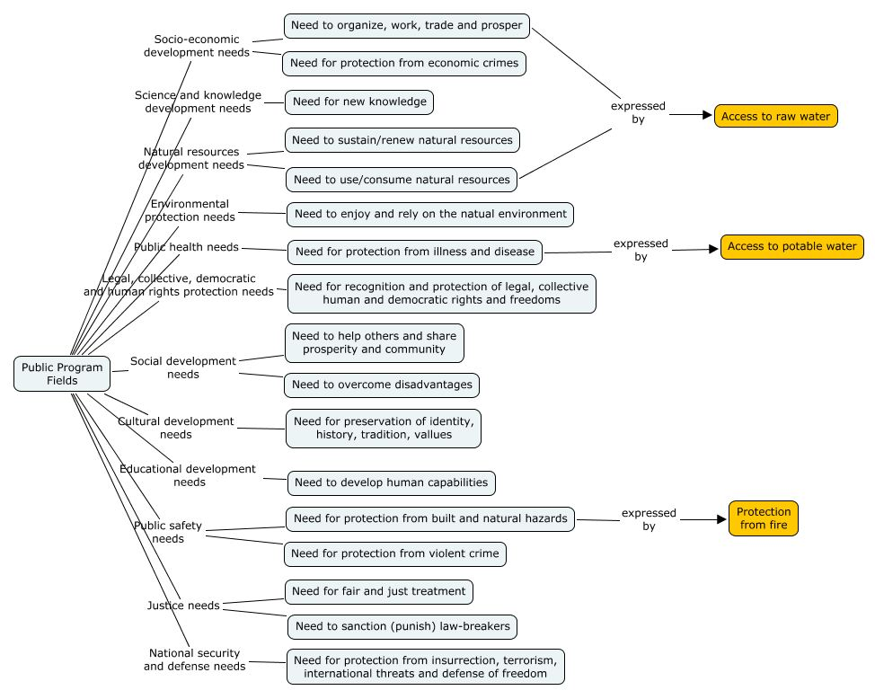

Program Fields - Enabling (a.k.a. Internal, Provider)
Classification of Enabling Needs (needs of internal or provider organizations)
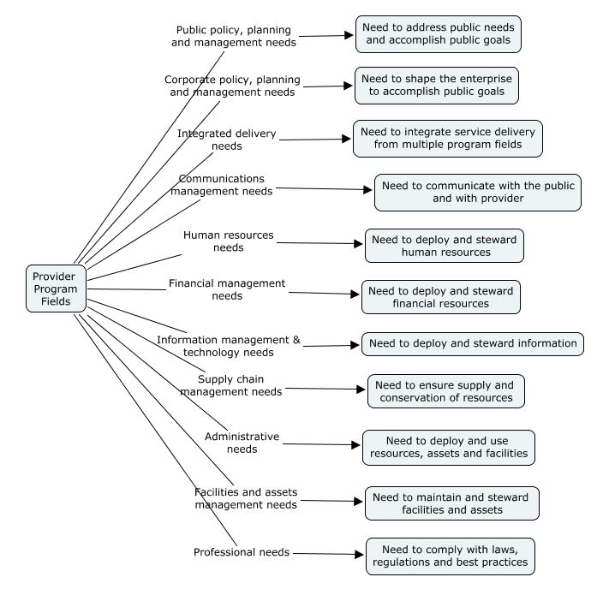

Service Output Types
The Service Output Type is an indicator of the nature of the work done by the government to perform the related Service (i.e. the Service’s Processes) and the way the government intends to measure the performance of that Service.
It is often the case that several types appear to apply. For example, a burial service’s Output (an interment) could be classified as a:
- Cultural & Recreational Encounter (supporting community values)
- Period of Permission (to occupy the cemetery), or
- Period of Protection (perpetual care of the site).
The choice from multiple feasible options should be based primarily on the ‘highest and best’ accountability assumed by the government for the Service, and secondarily on the nature of the Service’s Processes for which the government is responsible.
Service Output Types
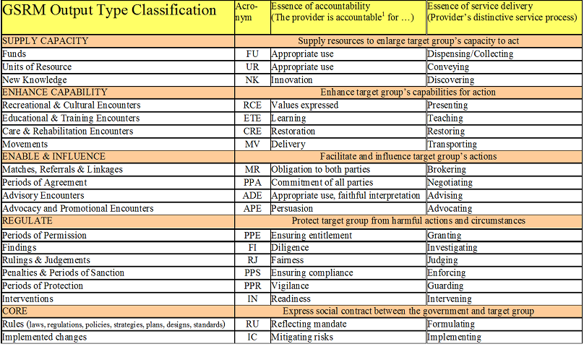

Constructs (to come)
Explains the specialized views of an MRM model used to analyze government operations
Program Logic Models (PLMs)
Service Integrated Accountability Models (SIAMs)
Program Service Alignment Models (PSAMs)

Use Cases (to come)
Describes the various types of analysis for which an MRM model can be used

MRM Metamodel Diagrams
Diagram Index
- MRM Overview - the complete Metamodel
- Metamodel Essentials - key code tables
- Organization Structure - centred on Organization roles
- Services - centred on Services

MRM Overview (Complete Metamodel)
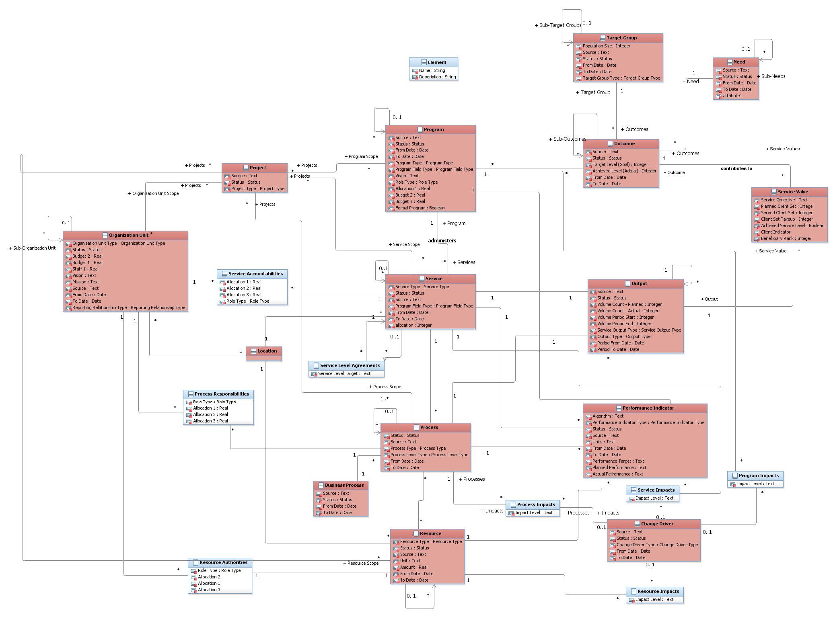

Metamodel Essentials – Key Code Tables

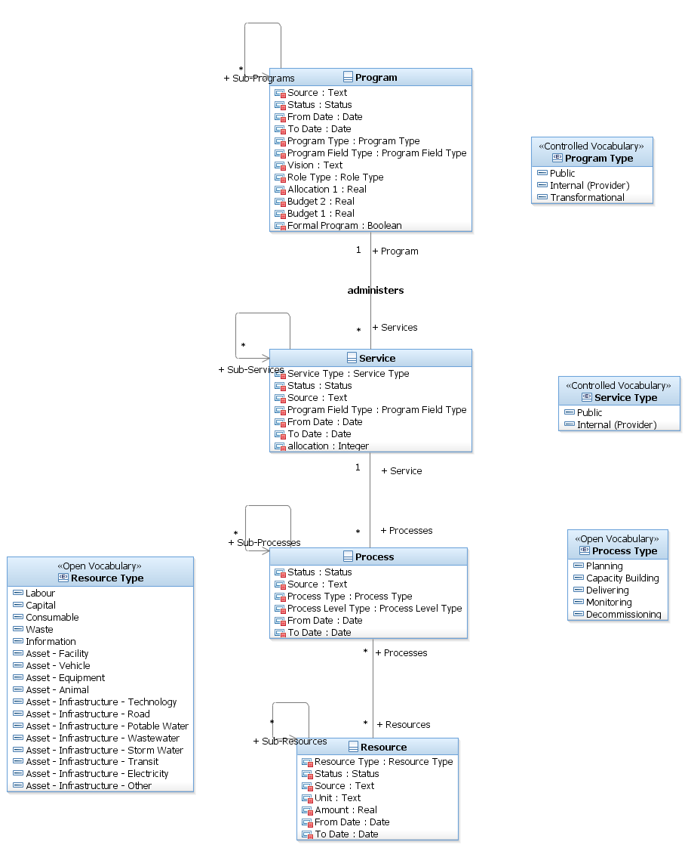

Organization Structure (Centred on Organization Roles)
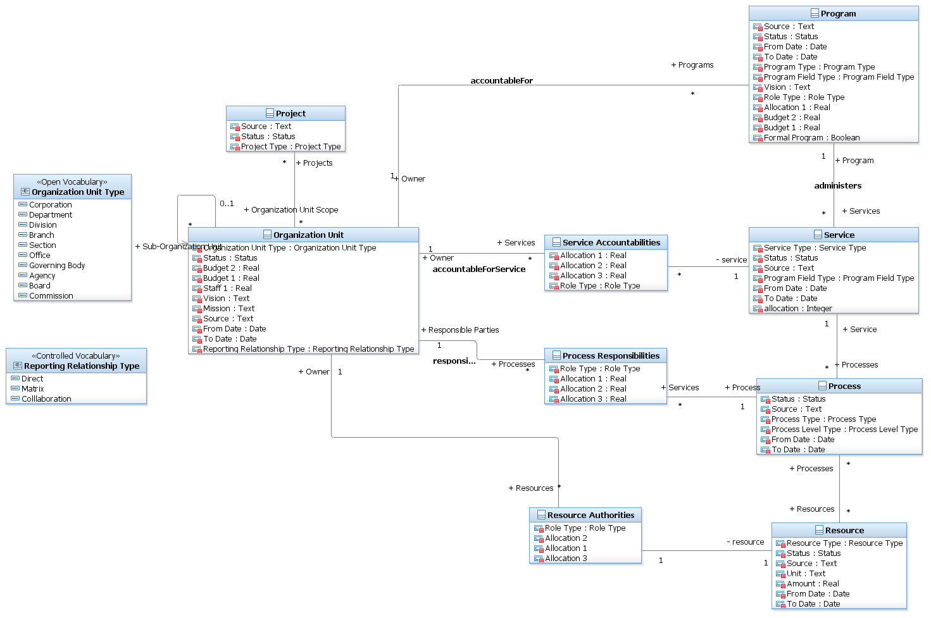

Services (Centred on Services)
